评分与评语：

**台州学院**

**电子与信息工程学院实验报告**

班级 计算机 学号 2462710034L 中文姓名 仙女

实验课程： Java程序设计基础

实验项目： Experiment 4 Java Object-Oriented Programming

**NOTE：**

**When pasting code, please do not use a black background. Otherwise, when the teacher prints your assignments at the end of the semester, it will be a mess of black.**

实验日期： 年 月 日

**Project: The Triangle Class**

Problem Description:

Design a class named Triangle that extends GeometricObject. The class contains:

* Three double data fields named side1, side2, and side3 with default values 1.0 to denote three sides of the triangle.
* A no-arg constructor that creates a default triangle.
* A constructor that creates a triangle with the specified side1, side2, and side3.
* The accessor methods for all three data fields.
* A method named getArea() that returns the area of this triangle.
* A method named getPerimeter() that returns the perimeter of this triangle.
* A method named toString() that returns a string description for the triangle.

For the formula to compute the area of a triangle, see Exercise 5.19. The toString() method is implemented as follows:

**return** "Triangle: side1 = " + side1 + " side2 = " + side2 +

" side3 = " + side3;

Draw the UML diagram that involves the classes Triangle and GeometricObject. Implement the class. Write a test program that creates a Triangle object with sides 1, 1.5, 1, color yellow and filled true, and displays the area, perimeter, color, and whether filled or not.

Design:

Draw the UML class diagram here

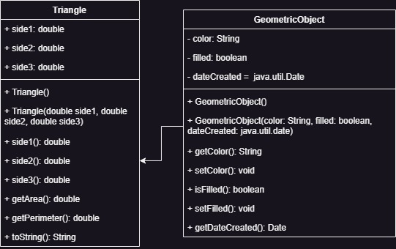

Coding: (Copy and Paste Source Code here. Format your code using Courier 10pts)

public class Exercise11_01 {

public static void main(String[] *args*) {  
 Triangle triangle = new Triangle(1, 1.15, 1);  
 triangle.setColor("yellow");  
 triangle.setFilled(true);  
  
 System.out.println("The area is " + triangle.getArea());  
 System.out.println("The perimeter is "  
 + triangle.getPerimeter());  
 System.out.println("The triangle is filled: " + triangle.isFilled());  
 System.out.println(triangle);  
 }

}

import java.util.Date;  
  
public class GeometricObject {  
 private String color = "White";  
 private boolean filled;  
 private Date dateCreated;  
  
 public GeometricObject() {  
  
 }  
  
 public GeometricObject(String *color*, boolean *filled*) {  
 this.color = *color*;  
 this.filled = *filled*;  
 dateCreated = new Date();  
 }  
  
 public String getColor() {  
 return color;  
 }  
  
 public void setColor(String *color*) {  
 this.color = *color*;  
 }  
  
 public boolean isFilled() {  
 return filled;  
 }  
  
 public void setFilled(boolean *filled*) {  
 this.filled = *filled*;  
 }  
  
 public Date getDateCreated() {  
 return dateCreated;  
 }  
}

public class Triangle extends GeometricObject{  
 private double side1 = 1.0, side2 = 1.0, side3 = 1.0;  
  
 public Triangle() {  
 }  
  
 public Triangle(double *side1*, double *side2*, double *side3*) {  
 this.side1 = *side1*;  
 this.side2 = *side2*;  
 this.side3 = *side3*;  
 }  
  
 public double side1() {  
 return side1;  
 }  
  
 public double side2() {  
 return side2;  
 }  
  
 public double side3() {  
 return side3;  
 }  
  
 public double getArea() {  
 return (side1 * side2) / side3;  
 }  
  
 public double getPerimeter() {  
 return side1 + side2 + side3;  
 }  
  
 *@Override* public String toString() {  
 return "Triangle{" +  
 "side1=" + side1 +  
 ", side2=" + side2 +  
 ", side3=" + side3 +  
 '}';  
 }  
}

Testing:

Demonstrate the triangle in TestTriangle Java class, create a main method, create a new object *triangle* with the parameter 1, 1.15, 1 for each side of the triangle. Set the elements such as the color and whether it’s filled or not. Get the elements of the triangle like the area and the perimeter then print it out to the screen.